*C*

*hernobyl*

*C*

*hildren*

*C*

*ancer*

*C*

*are*

*C*

*ardiff*

Heol Llanishen Fach Rhiwbina Cardiff CF14 6LB

53

Tel: +44 (0)29

20

624730

www.five

-

cs.org info@five

-

cs.org



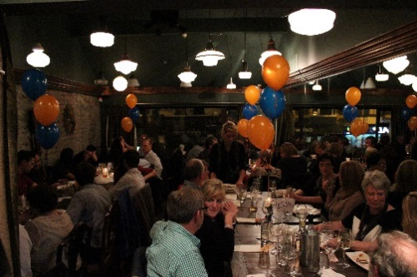 Registered Charity Number: 1077451

On 11th November we began our year of fundraising in style at the newly opened Miss Jones restaurant in Cardiff. We all enjoyed a meal and entertainment where we raised £1090.40!

A big thank you goes to the staff at Miss Jones and for all those that attended for helping us with a great start to the Five C’s year.

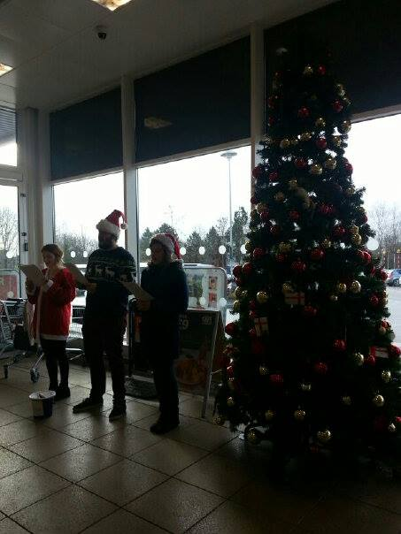

Over the Christmas period we held Carol Singing and bucket collection at Sainsbury’s, Thornhill. We raised £560! Thanks again to all those at Sainsbury’s for regularly letting us use the premises for all that we do.

The mum of one of our team leaders, Bethan Sexton, Rhian Sexton, very kindly held a Mexican evening in their village in February raising £876.95. We are so lucky to have the support from people like Rhian.

In April, we once again held our annual cocktail party on the theme of a traditional British Garden Party.

Once again we are so grateful to all our fantastic members who helped the day be the wonderful success that it was and for all those that came. We raised a fantastic £836.15!

We hope that you all had a wonderful time.

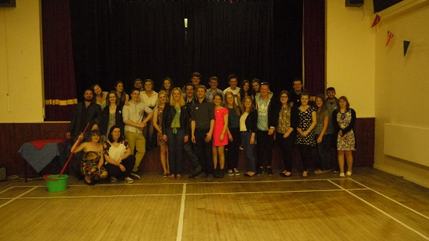

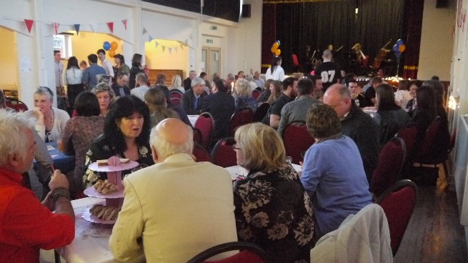

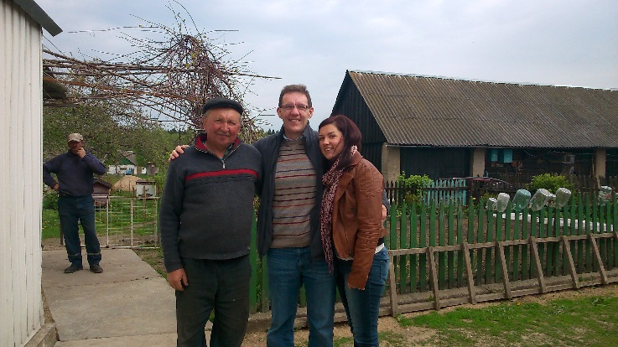

In May Beth went to Belarus to deliver this years donation of £4450. This money will help the Hospice pay to run the summer camp this summer. Beth also organised our house and car for the summer, made lots of visits and began shopping for everything that we need for a successful summer.

Along with Five C’s business, Beth also took her Dad along to help with the maintenance of some Hospice equipment. We are so grateful for the unwavering support of Beth’s parents.

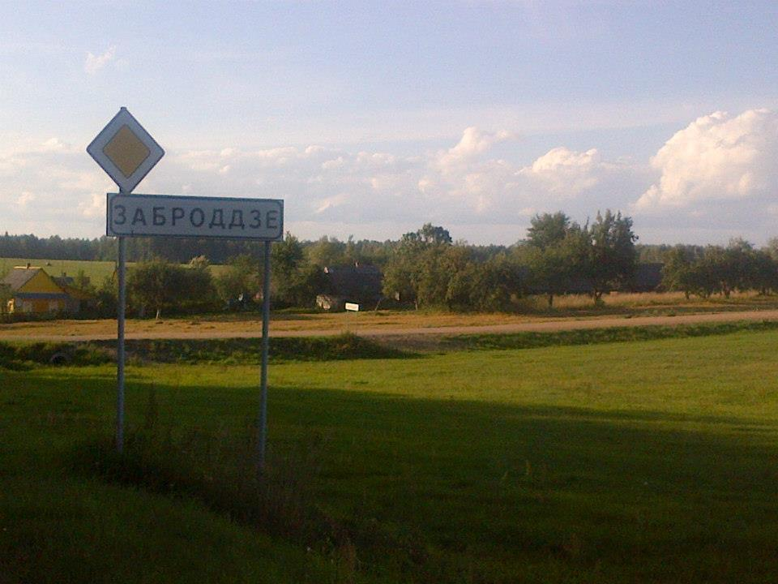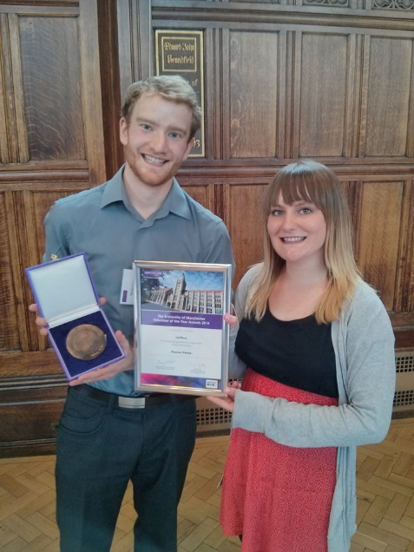

Please see our website at [www.five-cs.org](../../../../../../../AppData/Local/Microsoft/Windows/Temporary%20Internet%20Files/Content.IE5/4WAWOZ52/www.five-cs.org), our Facebook page (search [Chernobyl Children Cancer Care Cardiff](https://www.facebook.com/pages/Chernobyl-Children-Cancer-Care-Cardiff-The-5Cs/134001776683923?ref=hl)) or our Twitter account ([@FiveCsCardiff](https://twitter.com/FiveCsCardiff)) for more detailed and up to date information, photos, contact information and where you can donate safely.

## Don’t forget to remember us while you shop by registering on [www.easyfundraising.org.uk-](http://www.easyfundraising.org.uk-) it won’t cost you anything! Thank You and we wish you a lovely summer!

### Zac and Beth

However the activity doesn’t stop just because we’re in Zabrodya . . . July will see two major bike rides. First off we have a group cycling through five places beginning with C- ‘The Five C’s does The Five C’s’. The next week sees a very generous supporter, Kyle Beal, cycles from Bangor to Cardiff Bay.

Please see our website and facebook to support them if you can.

This Summer’s volunteer project will begin on June 18th for 10 weeks, with a total of 26 volunteers travelling to Zabrodya to help run activities on the summer camp in 6 groups. This will be the 9th year of the project and we are continually amazed at the interest and enthusiasm coming from all over Cardiff. We hope everyone enjoys themselves and watch out for our summer report that we will send in September to let you all know how it went!

On May 18th our trustee Thomas Pacey – once again did us proud – completing the Manchester 10km Run dressed as a Babushka raising over £200! Don’t stop running Tom!

On May 9th we were very saddened to have to say goodbye to a very generous gentlemen, Michael Reilly. We feel very honoured to have met such a kind man and the £1500 he left us in his will is going to help us more than he could have imagined.

In the Summer we plan to plant a tree in honour of mike. Photos to come.

On May 8th our trustee Thomas Pacey won the Volunteer of the Year Award at the University of Manchester nominated by our team leader Rhiannon Heslop. Along with this he received the prestigious Social Responsibility Award. This is a fantastic recognition for Tom and for all of us on the team and a reminder of how lucky we are to have Tom and all the other wonderful young people right behind us. Congratulations!